**Preprocess**:

Defining Contour

Gray Scale

Original Image Grayscale Image Threshold Image

**Figure: Preprocess**

**Finding Possible Characters**:

Find Possible Char ()

**Finding list of the list of Matching Character**:

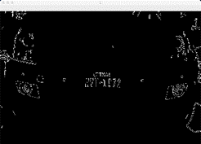

Find list of the list of Matching Char ()

**Extract Possible plates:**

Extract Plates ()

**